FLUTTER INSTALLATION

Install flutter from this link <https://docs.flutter.dev/get-started/install/windows/desktop?tab=download>

1. Choose the development platform according to your software

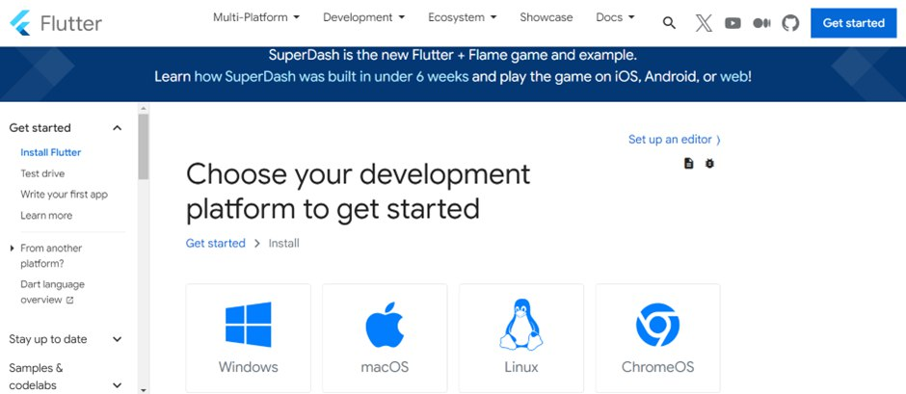

1. Download the latest Visual Studio Code and Android Studio

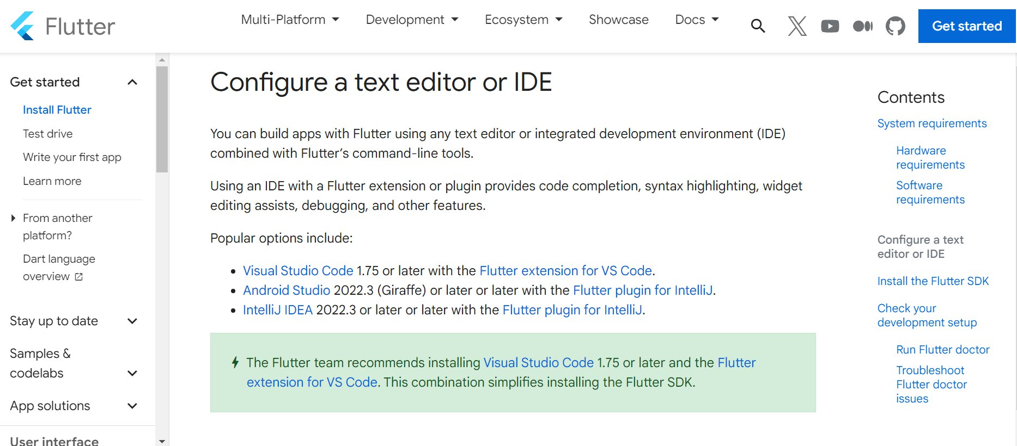

1. Install Flutter SDK by clicking the blue button 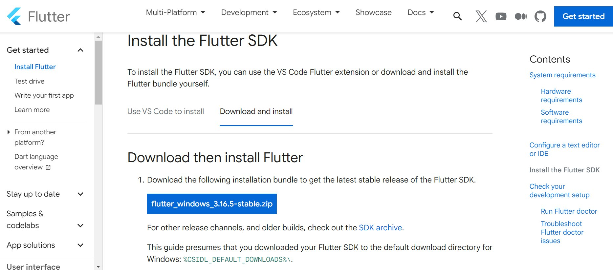

4. Search for edit environment variables and click on the ‘Environment Variables…’ 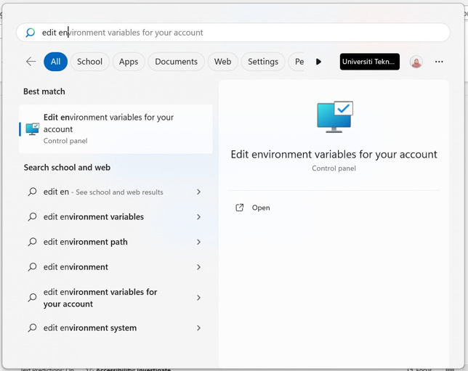

5. Double click on the ‘Path’ in ‘User variable..’ and add the location of the Flutter bin

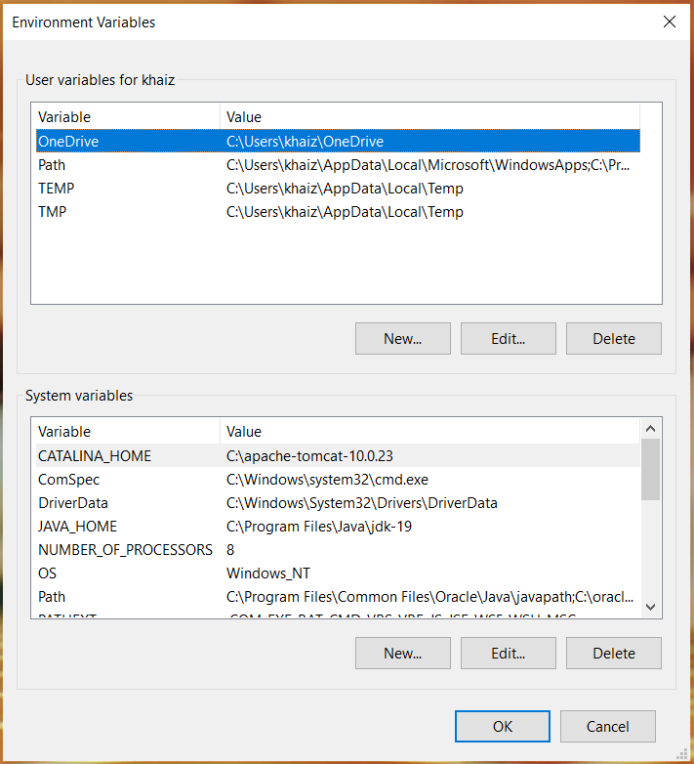

6. Open Command Prompt and type in ‘flutter’ to check if Flutter had been installed 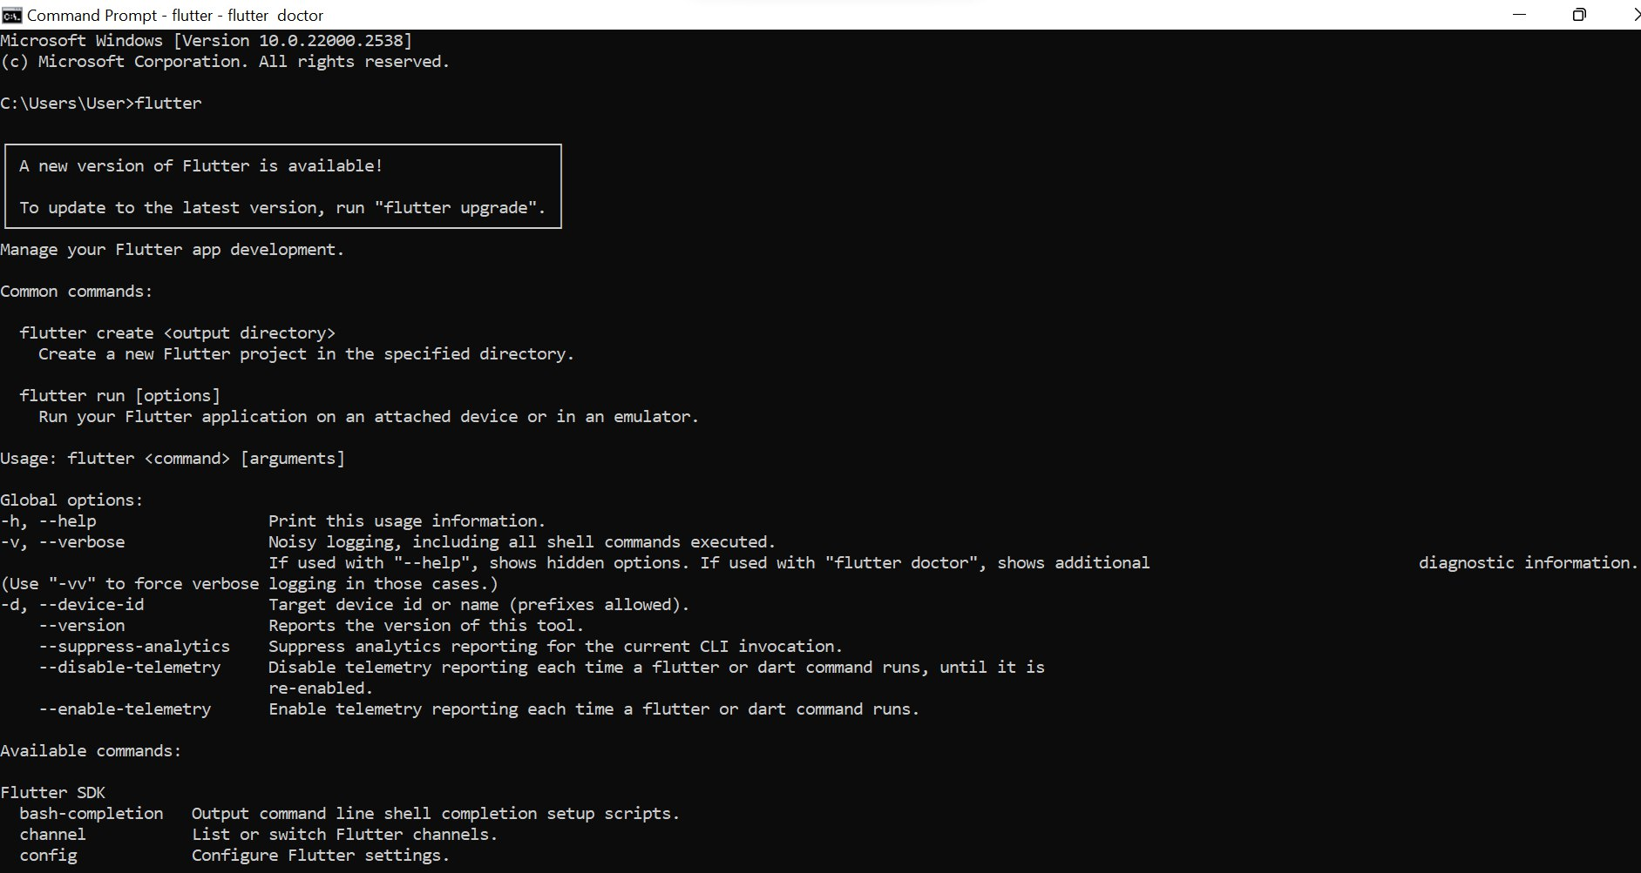

7. Type in ‘flutter doctor’ to check all details are checked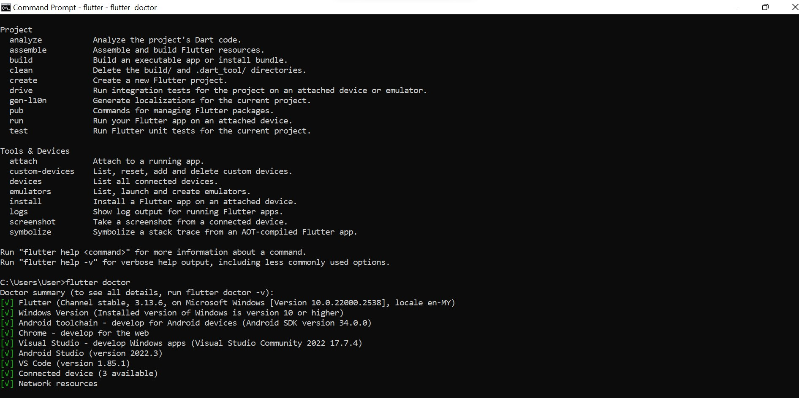

8. Successfully download Flutter and run the emulator